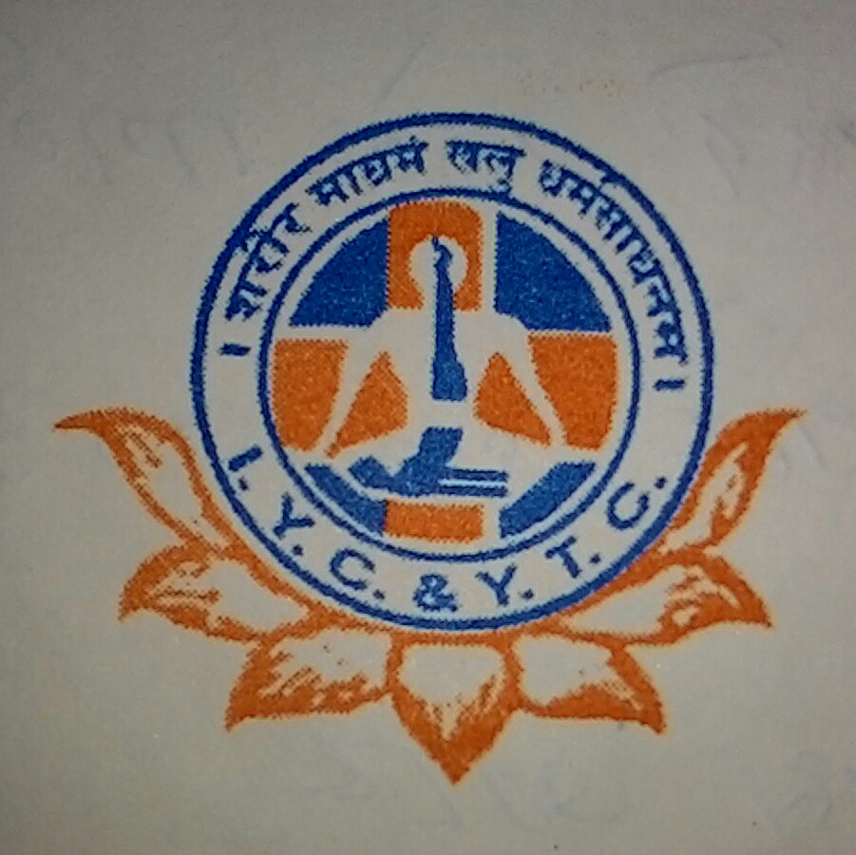

**SWAMI SHIVANANDA YOGJYOTI SEWA KENDRA**

**DIBRUGARH**

**V.K.V. Path,Lachit Nagar,Dibrugarh**

**ASSAM: 786001**

**Website URL: http:// ssyjskdib2010.wix.com/yoga**

**Email id:** [**ssyjskdib2010@gmail.com**](mailto:ssyjskdib2010@gmail.com)

**Contact no. : 9957617391 / 9401512963**

***SYLLABUS for 1 year Yoga Teachers Diploma ( KAYAYOGI )***

|  |  |  |  |
| --- | --- | --- | --- |
|  | Duration | : | 12 months  **(LAST MONTH IS FOR EXAMINATION)** |
|  | Academic Session | : | OCTOBER TO SEPTEMBER |
|  | Educational Qualification | : | Minimum HSLC or HS passed under 10+2 system |
|  | Duration of Class | : | 48 days |
|  | Medium of Instruction | : | English, Assamese,Bengali & Hindi |
|  |  |  | (Non Residential regular classes) |

|  |  |  |  |
| --- | --- | --- | --- |
|  | Theory | : | 300 Marks |
|  | Practical | : | 200 Marks |
|  | **Total** | **:** | **500 Marks** |

***Subjects:--***

**1st Paper: - Yoga Introduction – Marks 100**

Yoga Introduction consist of study of Basics of Yoga, its definition, history of development, different yogic modalities in respect of different Yoga Sastras, Scientific definition of Yoga and its value in human life.

|  |  |
| --- | --- |
|  | * Definition of Yoga-different types of Yoga |
|  | * Origin & History of Yoga |
|  | * Various paths of Yoga |
|  | * Aim objective & Scope |
|  | * Utility of Yoga |
|  | * Study of Patanjal Yoga Darshan |
|  | * Hatha yoga Pradipika- origin and different types * Asana and Pranayam-definition, types and benefits * Mudra – definition, different types, benefits |
|  | * Study of diet – Diet principle, essential quality of diet, ideal diet, Swattik Diet |

**2nd Paper: - Yoga Vijyana – Marks 100**

Yoga Vijyana is consists of Study of different yogic modalities- their analytical study, mechanization and benefits.

|  |  |
| --- | --- |
|  | * Five Universal Commands – Ahimsa, Satya, Asteya, Brahmacharya, Apparigraha |
|  | * Universal Personel observances- Saucha, Santosa, Tapas, Svadhyaya, Isvara Prapti |
|  | * Asanas, Mudra, Sahaj Pranayam - different types, procedure, Mechanization. |
|  | * Yogic exercises & Other form of exercises |
|  | * Rajyoga Pranayam- procedure, Mechanisation & benefits. |
|  | * Principles of Yoga Practise. |
|  | * Prakittick Chikistya- different modalities |
|  | * Different forms of Naturopathy |
|  | * Water Therapy |
|  | * Dhouti, Basti, Neti, Sun-Bath, Hip bath, Footbath, Sitz bath, Sun bath – procedure, mechanization, benefits |

**3rd Paper: - Anatomy, Physiology & Pathology – Marks 100**

Anatomy & Physiology – brief knowledge of human body, different parts organs, glands their anatomical structure, location & function.

|  |  |
| --- | --- |
|  |  |
|  | * Oesteology- Study of Bones |
|  | * Arthrology – Study of Joints |
|  | * Myology – Study of Muscles |
|  | * Splanchnology – study of Viscera |
|  | * Liver, Stomach, Lungs, Gall bladder, Pancreas, Spleen. |
|  | * Systems of body: - Respiratory system, Digestive system, circulatory system & Urinery system. |
|  | * Blood – elements of blood, function of blood |
|  | * Endocrine Glands :- Pituitary, Thyroid, Thymus, Adrenal |
|  | * Study of common pathological reports: - Blood Urine & Stool. |

* ANATOMY: 40 marks
* PHYSIOLOGY: 40 marks
* PATHOLOGY: 20 marks

**PRACTICAL: 200 marks**

* Asana - 50
* Mudra - 20
* Pranayam - 20
* Sat karma - 50
* Anatomy & BP examination - 20
* Viva - 30
* Appearance & Dress code - 10

**Note:**

*Pass mark in theory papers is 40%.*

*Pass mark in practical is 50%.*

#############KNOW YOGA KNOW PEACE#################